# Sales Forecasting Screenshots

**Check for outliers**

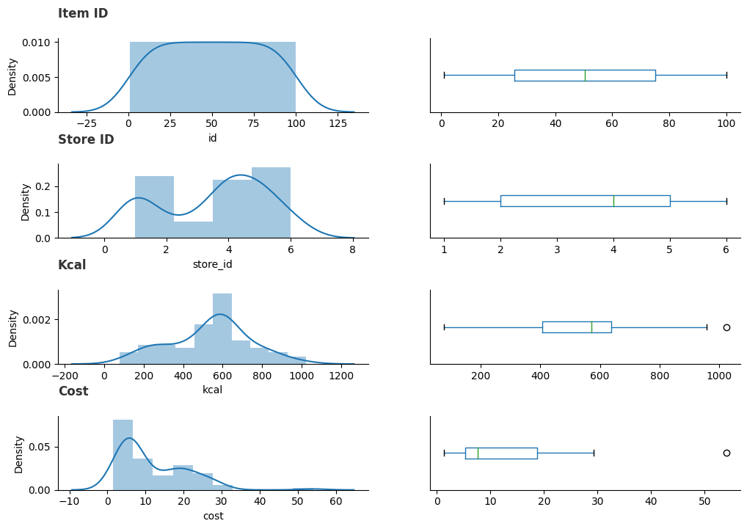

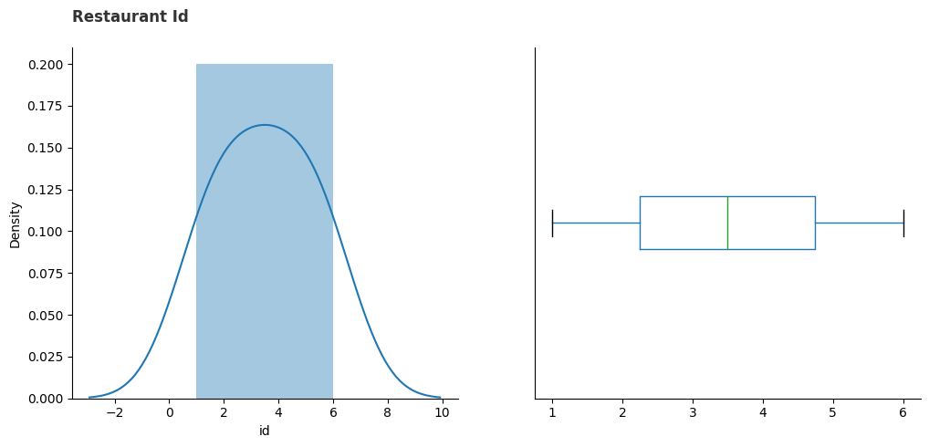

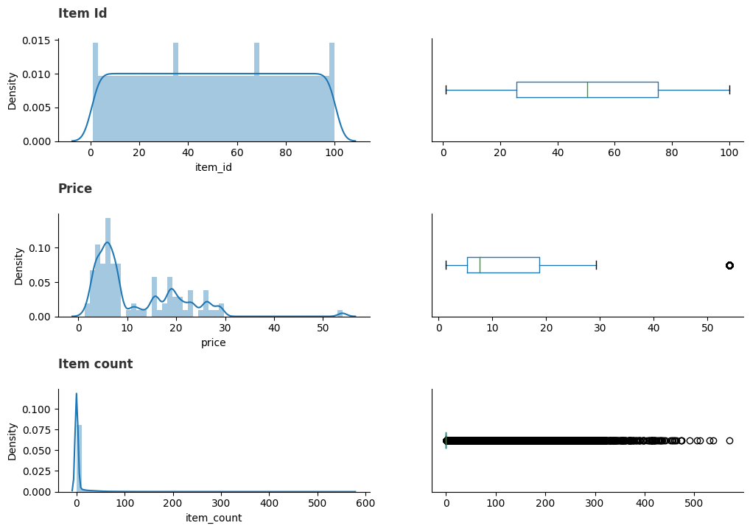

## **Exploratory data analysis**

#### ****1. Examining the overall date wise sales to understand the pattern****

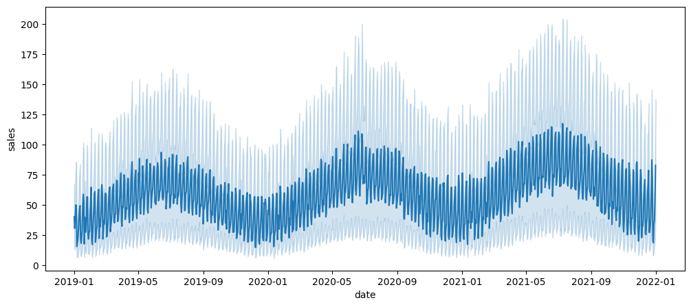

#### ****2. Sales fluctuation across different days of the week****

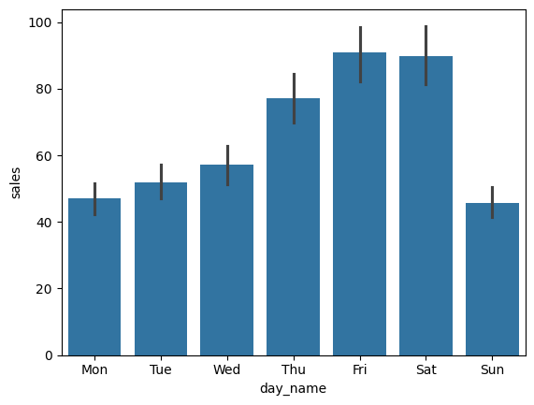

#### ****3. Trends in the sales data for different months of the year****

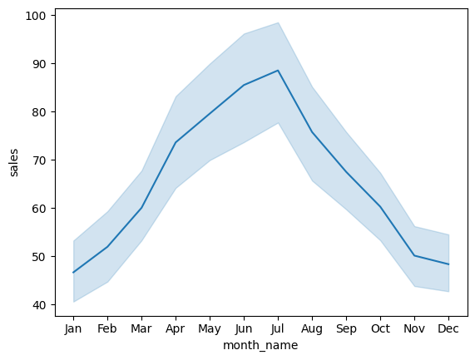

#### ****4. Sales distribution across different quarters****

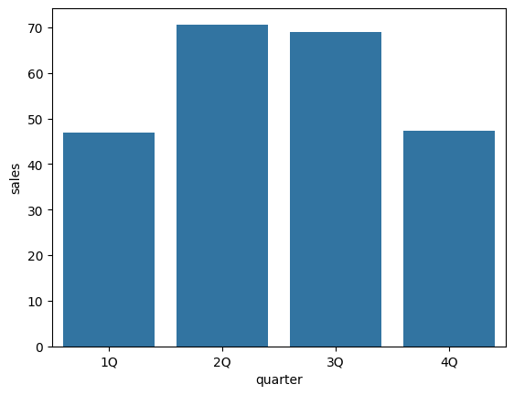

#### ****5. Comparing the performances of the different restaurants****

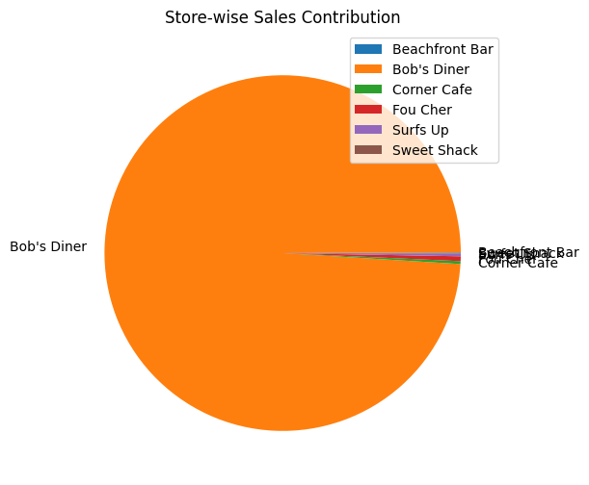

**Comparing sales for each restaurant across different years, months, and days**

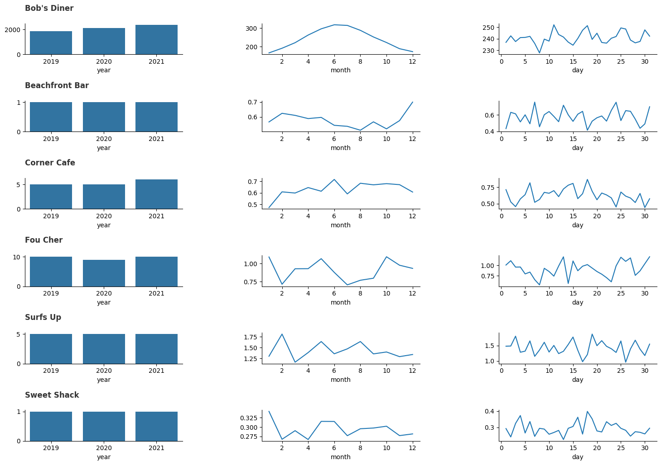

**Fetching the top 10 most popular items overall**

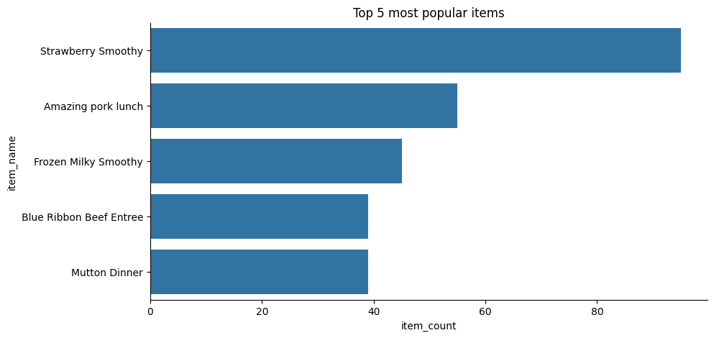

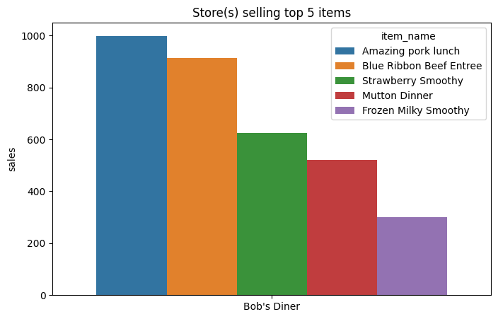

**Finding out the most popular item at each store**

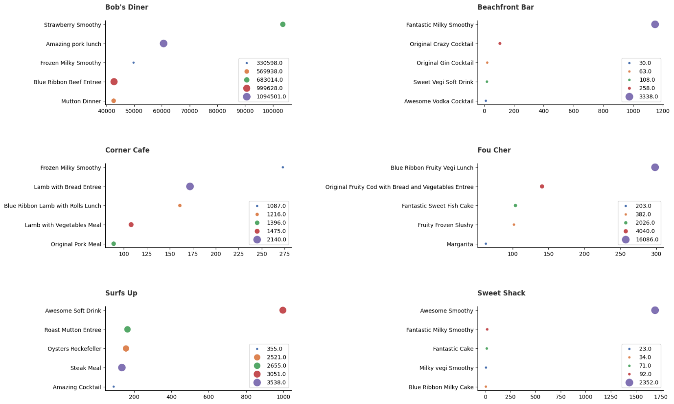

#### ****7. Checking if the store with the highest sales volume is also making the most money per day****

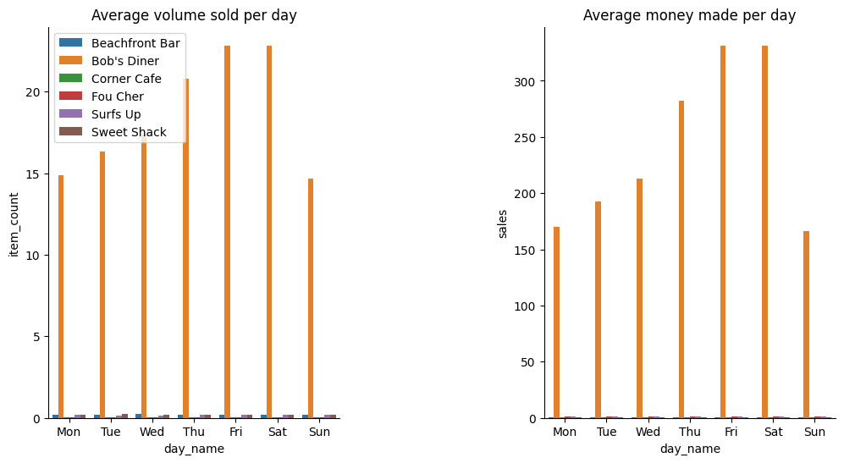

#### ****8. Identifying the most expensive item at each restaurant and its calorie count****

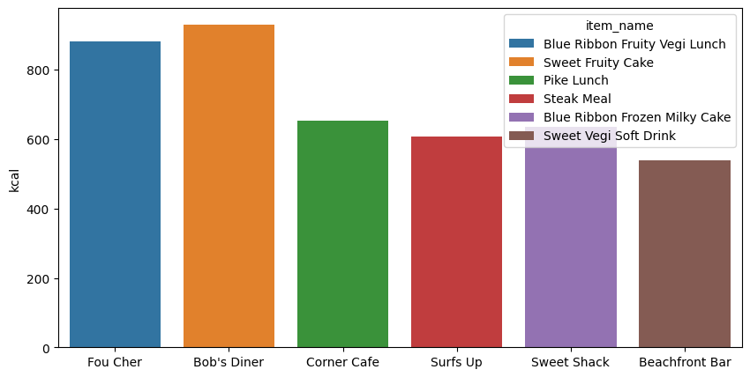

**Visualizing train and test data for each store**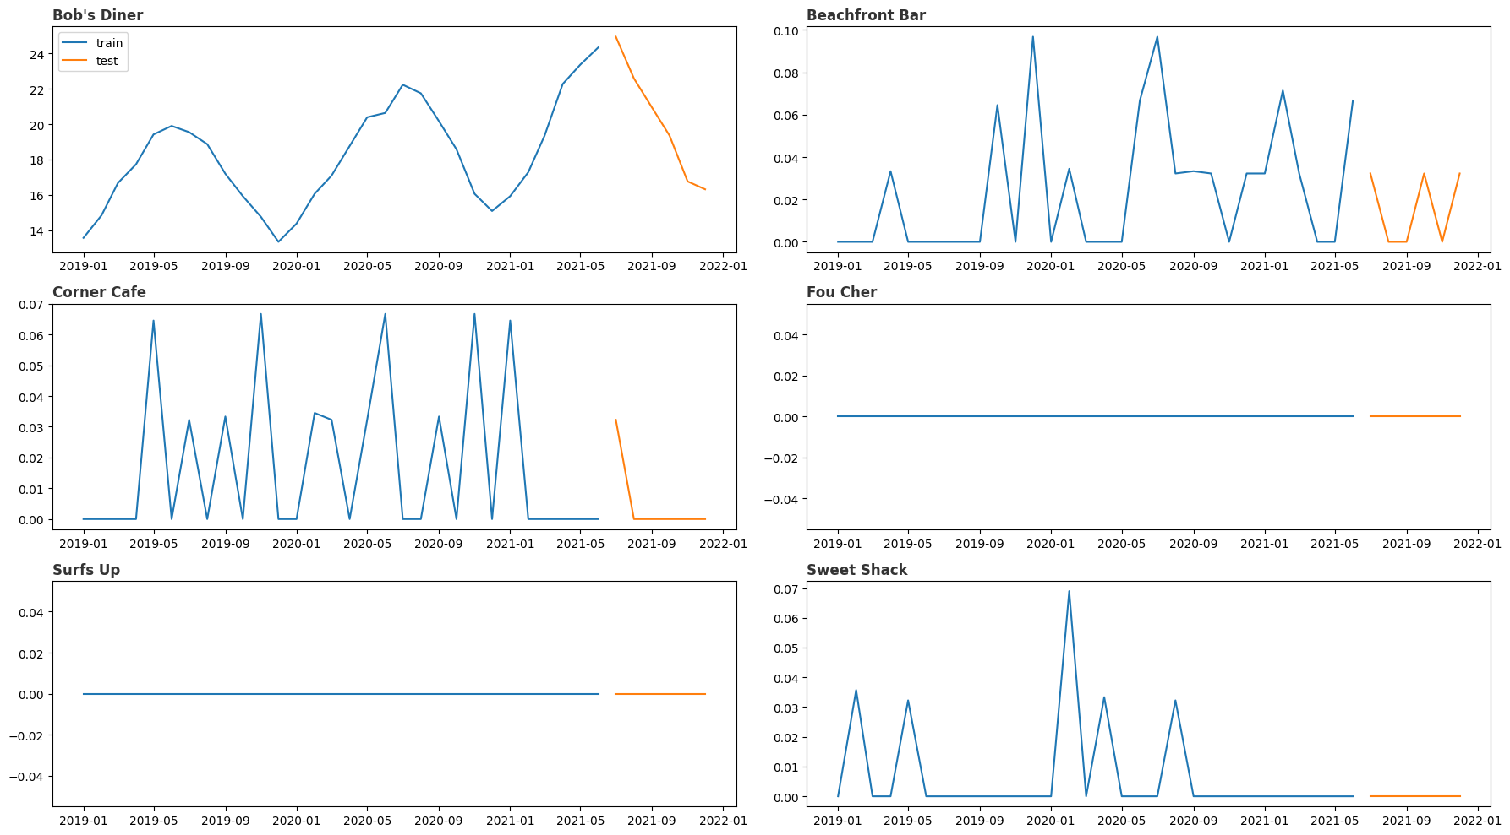

##### **Checking whether the time series data is stationary or not**

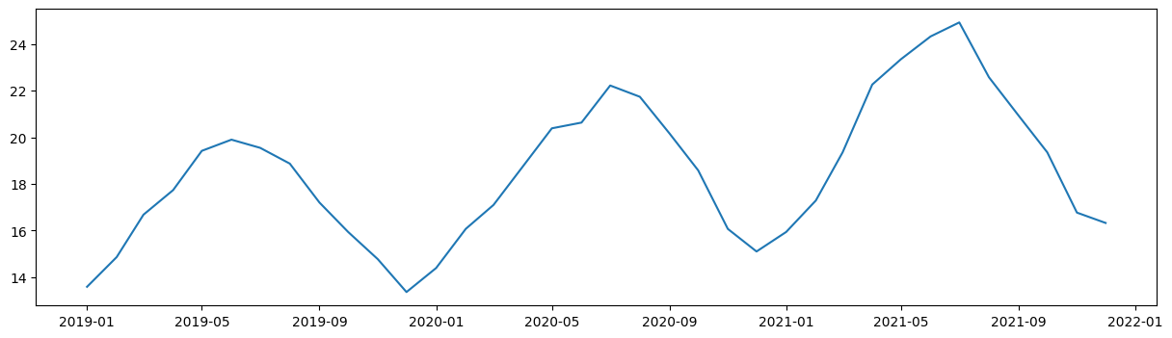

**Plotting original and log transformed data**

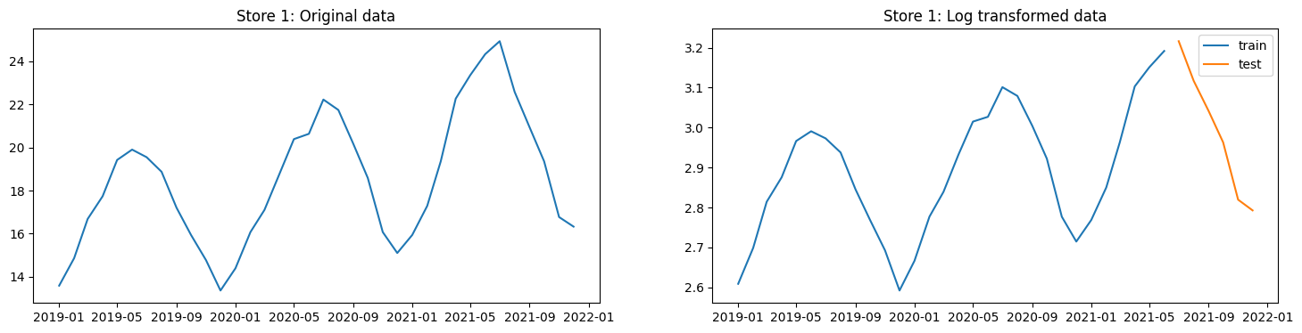

**Differencing**

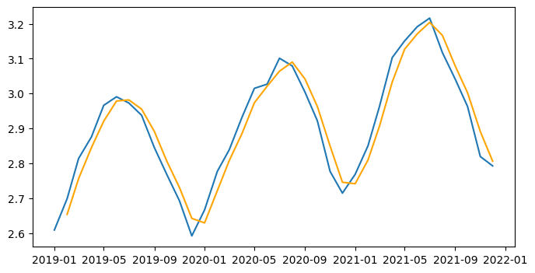

**Plotting the ACF and PACF curves**

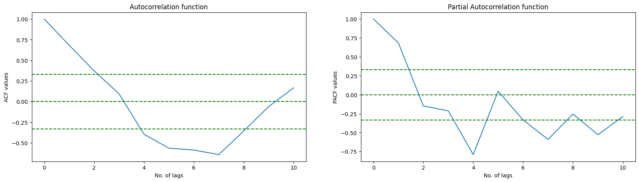

**Plotting the SARIMA model output**

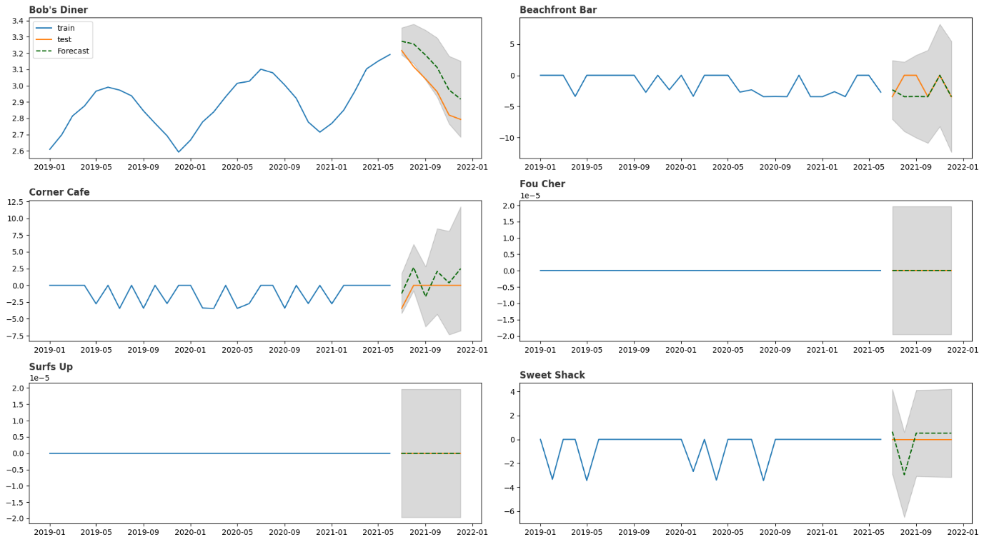

**SARIMA Model Diagnostics**

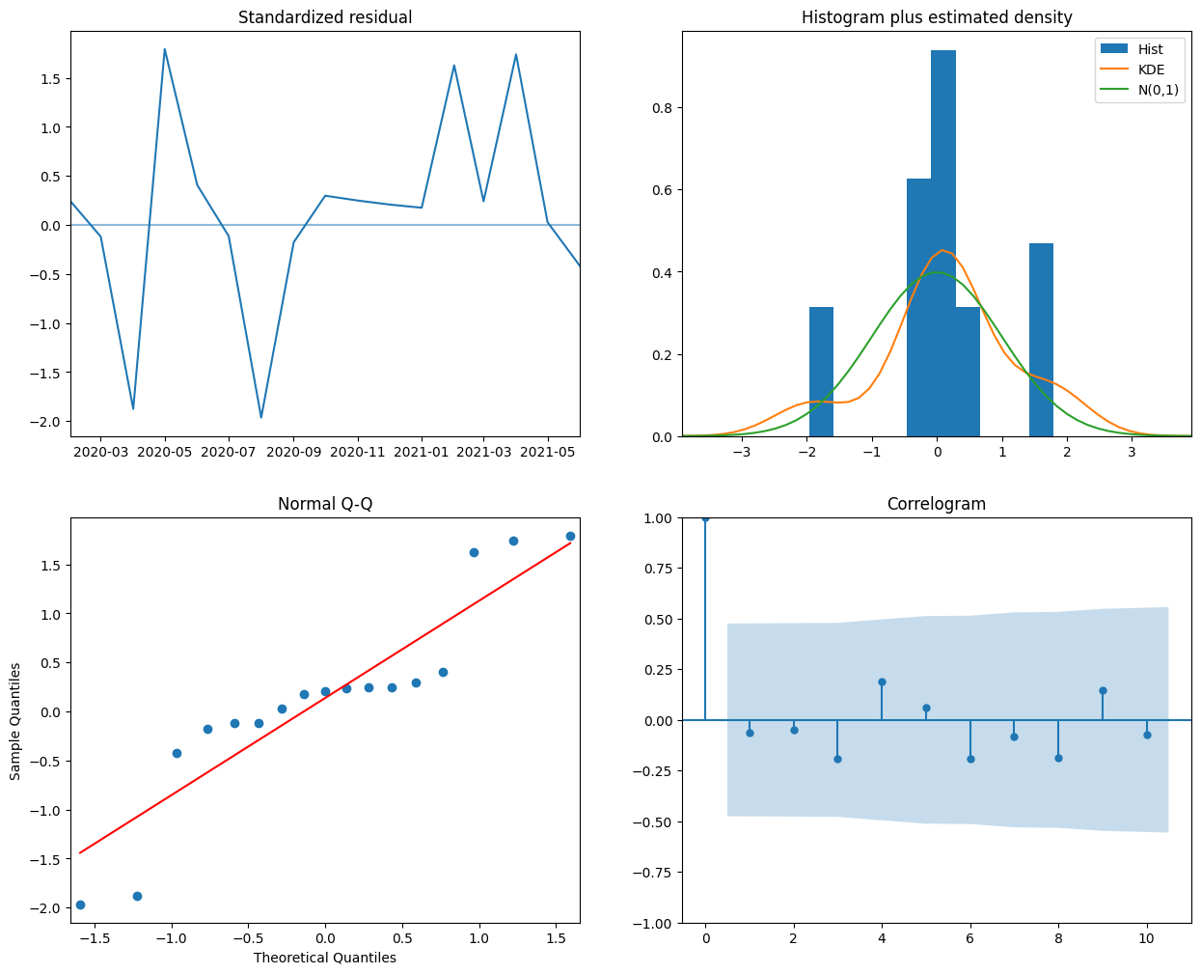

**Prediction using Facebook’s Prophet**

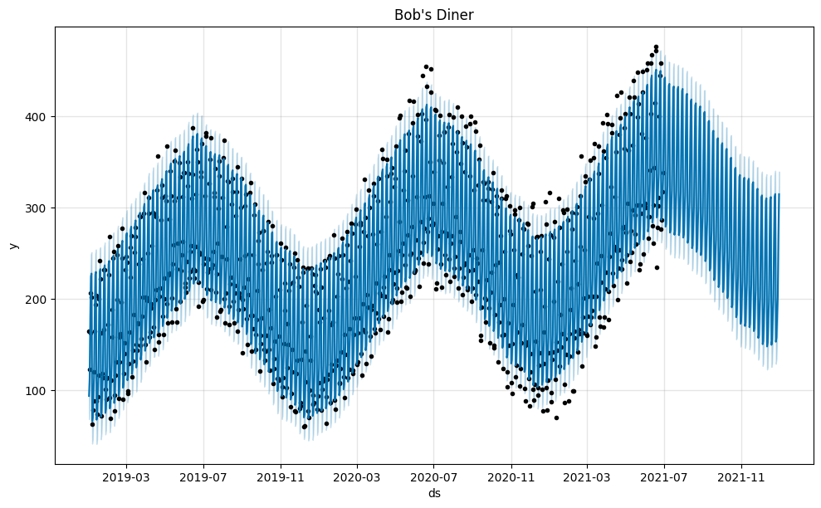

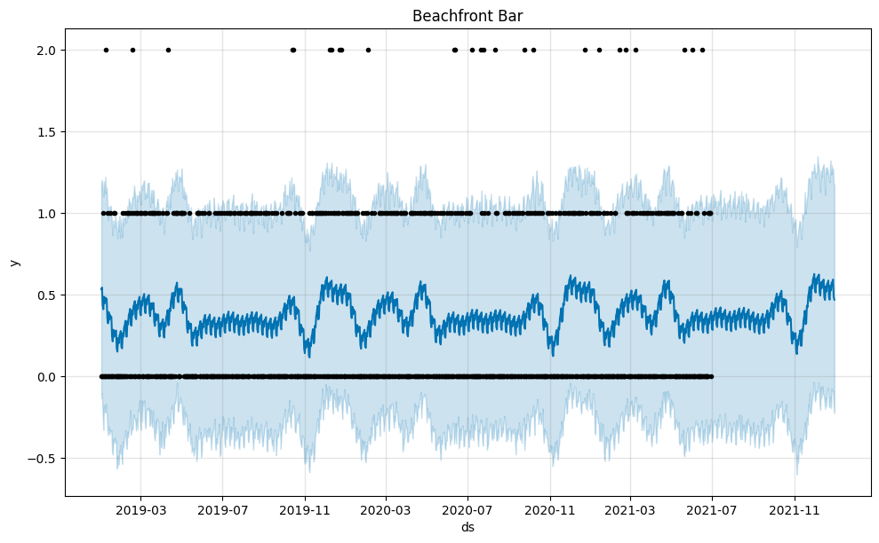

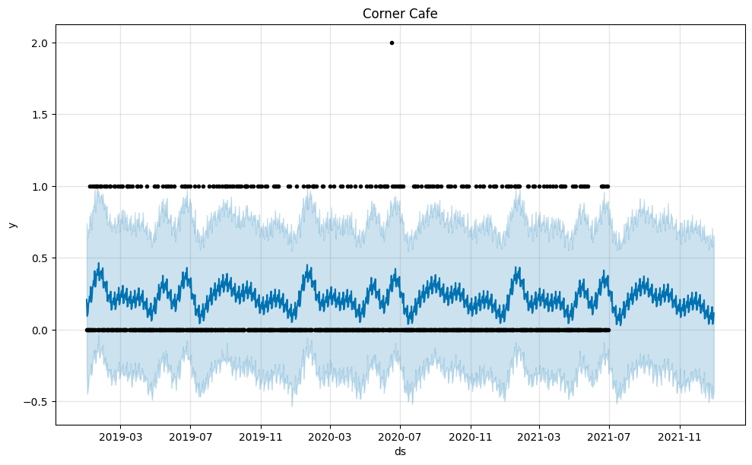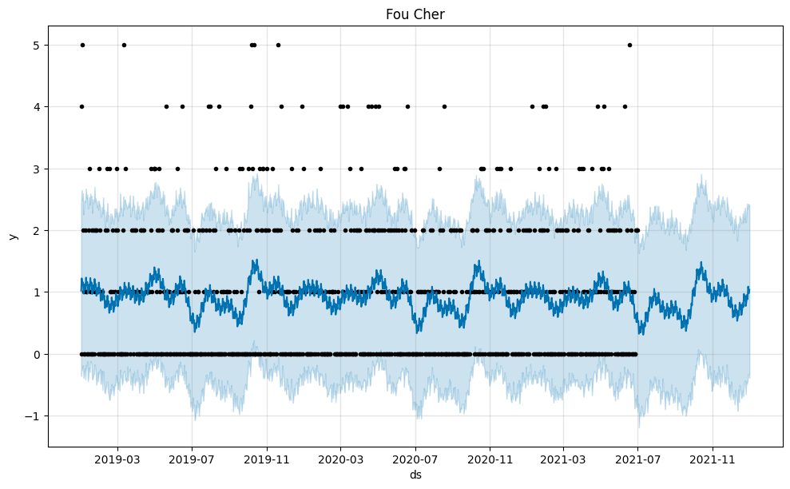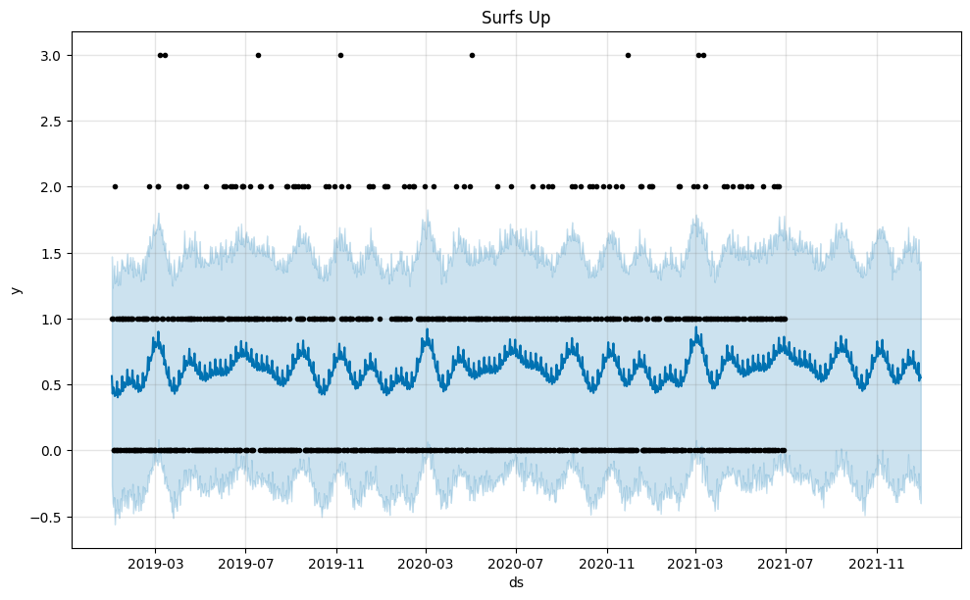

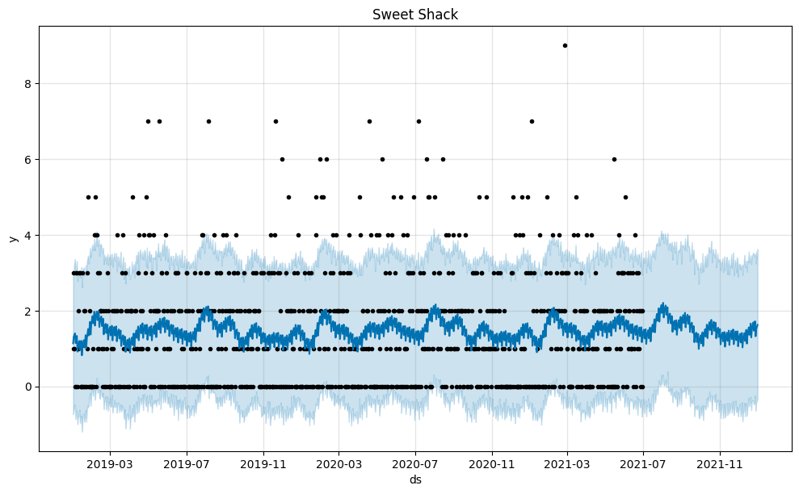

**Store 1 trends**

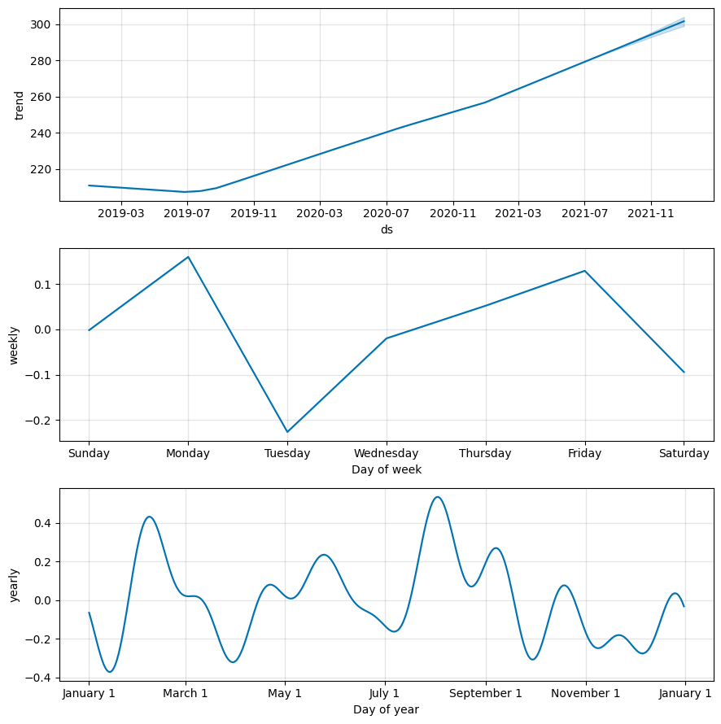

**Visualize sales volume and forecast for next year**

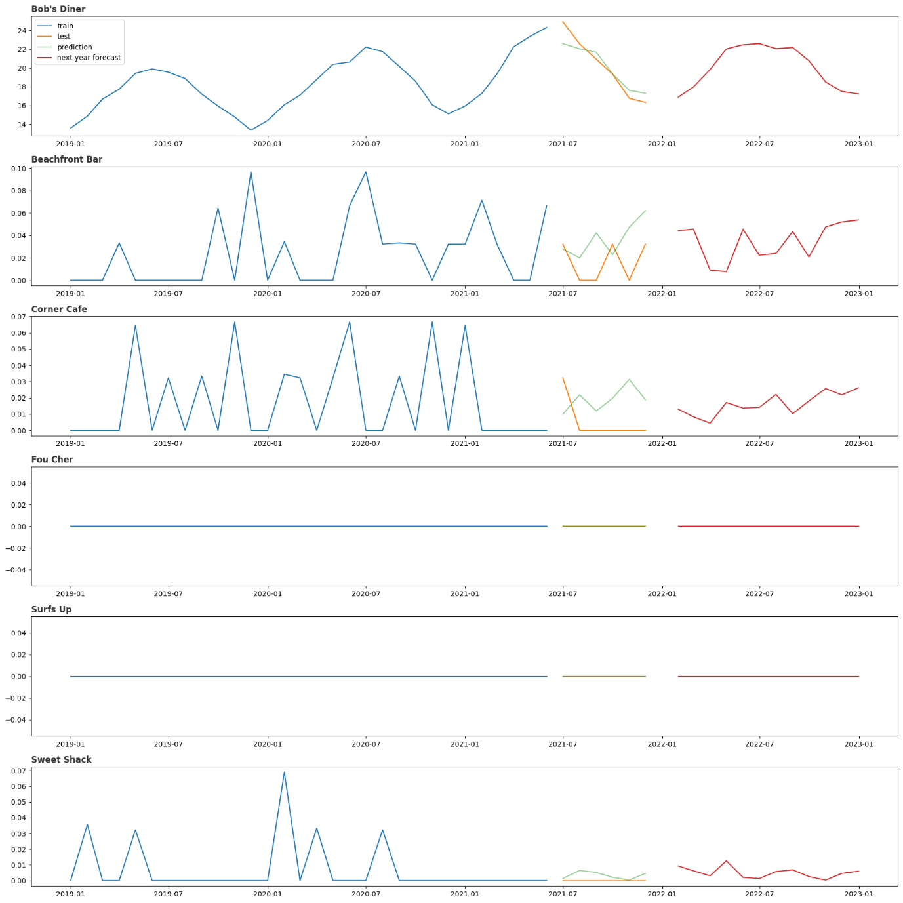

**Visualizing the predictions**

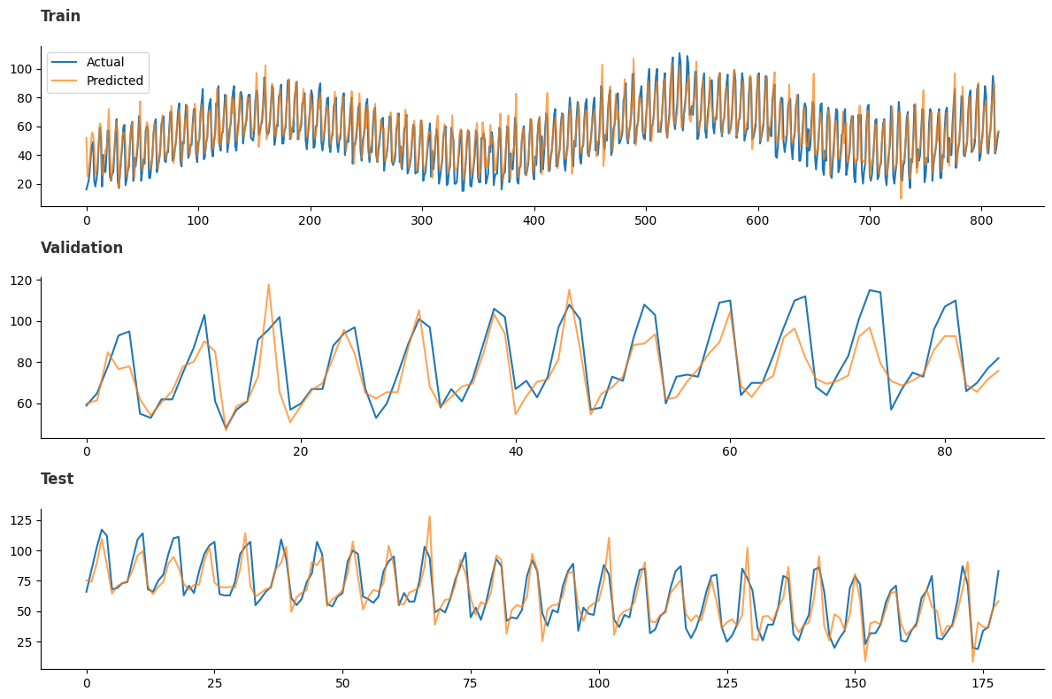

**Visualizing the forecast for next 3 months**

